ARMY PUBLIC SCHOOL, AHMEDNAGAR
SUBJECT : SCIENCE
QUESTION BANK OF CH. 9. SOIL
CLASS : VII
Q. MCQ'S
1. Soil provides………..
a. anchorage to the plants
b. shelter to many organisms
c. supplies water and nutrients to the plants
d. all of the above

2. The layer that is hard and difficult to dig is ............
a. Topmost layer
b. middle layer
c. layer with small lumps of rocks
d. bedrock

3. A certain sample of soil takes 15 minutes for 300 ml of water to percolate. Hence rate of percolation will be ............
a. 1/20 ml
b. 20 ml/min
c. 0.020 ml/min
d. 0.20 lit/min

Q2. Assertion_ Reasoning
In each of the following questions, a statement of Assertion is given and a corresponding statement of Reason is given just below it. Of the statements, given below, mark the correct answer as:
(a) Both assertion and reason are true and reason is the correct explanation of assertion.
(b) Both assertion and reason are true but reason is not the correct explanation of assertion.
(c) Assertion is true but reason is false.
(d) Both Assertion and Reason are false.
1. Assertion:- There is a demand to ban the polythene bags and plastics.
Reasoning:- Polythene bags and plastics pollute the soil. They also kill the organisms living in the soil.

2. Assertion:-The soil can be classified as Sandy and loamy.
Reasoning:- The size of particles in a soil has an influence on its properties

3. Assertion:- The air above the land is shimmers.
Reasoning:- The vapour coming out of the soil reflect the sunlight and the hot air above the soil seems to Shimmer.
Q3. Short answers
1. What is present in the soil that helps the growth of crops?
2. Mention what on adding to the soil in more quantity can render the quality of soil?
3. A farmer grows different types of crops season after season. What is this method of growing crops called as?
Q4. Application based questions
1. Daniel had dig few metres deep pit in his garden to observe different layers of soil. He Found that
a) X layer at the top is rich in Y. What does X and Y stand for?
b) Which other layers would be seen below the first layer?

2. Bikhu and his father are potter's by profession. They use P soil to make earthenpots .
a. Identify P.
b. Which qualities of soil P makes it suitable for pottery?

3. Rambhau purchased a piece of land. He is unable to understand which crop he can grow in that field. He visited a farm School to test the soil and learnt factors affecting the soil profile.
a. What could be those factors affecting soil profile?
b. If the soil in his field is clayey or loamy, which crops can he grown in each case.

Q5. Paragraph based questions
You probably know that soil is formed by the breaking down of rocks by the action of wind, water and climate. This process is called weathering. The nature of any soil depends upon the rocks from which it has been formed and the type of vegetation that grows in it. A vertical section through different layers of soil is called soil profile. Each layer differs in texture, colour, depth and chemical composition. These layers are referred to as horizons.
The uppermost horizon is generally dark in colour as it is rich in humus and minerals. The humus makes the soil fertile and provides nutrients to the growing plants. This layer is soft porous and retain more water. It is called the topsoil or the A horizon
1. Which are the factors that affect the weathering of rocks?
2. Paheli added handful of soil to a glass of water. What do you think she must have observed. (Write in points)
3. Why is the texture of topsoil very important for a farmer.

QUESTION BANK OF
CH. 10.Respiration in Organisms
CLASS : VII
Q .MCQs
- During heavy exercise we get cramps in the legs due to accumulation of
a) Carbon dioxide
b) Lactic acid
C) Water
d) Oxygen
2) The average breathing rate of normal person is………………
a) 25 – 27 times per minute
b) 8 – 10 times per minute
c) 15 – 18 times per minute
d) 72 – 80 times per minute
3) An organism which can breathe through both its skin and lungs is……………………………..
a) frog
b) earthworm
c) fish
d) human beings
Assertion and reasoning questions :
- Assertion : The breathing rate of a person increases during heavy exercise
Reason : During heavy exercise the demand of energy in the body increases
- A
- B
- C
- D
- Assertion : During inhalation the ribs move outward and the diagram moves in the down ward direction
Reason : During breathing process there are changes in the size of the chest cavity .
- A
- B
- C
- D

- Assertion : The skin of an earthworm feels moist and slimy on touching .
Reason : Every organism breathes with the help of its lungs .
- A
- B
- C
- D
Q ) SHORT ANSWERS QUESTIONS
- What is cellular respiration ?
- Why should we eat regularly ?
- We should cover our nose while sneezing, give reason.
- How does a fish breath ?

Q) Application based questions :
1) Which organism is described in the information given below:
i) respires anaerobically
ii) used to make wine
iii) reproduce by budding
- Potato
- Grapes
- Yeast
- Mucor

- In inhaled air the percentage of X is more as compared to percentage of Y .
- X : Oxygen , Y : Carbondioxide
- X : Carbondioxide , Y : Oxygen
- X : Carbondioxide , Y : Nitrogen
- X : Nitrogen , Y : Oxygen

- A person puts warm water in an aquarium, thinking that the fish would be more comfortable in it. However, the fish died. What can be the reason for this ?
- The concentration of oxygen decreases in warm water
- the concentration of carbon dioxide increase in warm water
- fish cannot bear the extreme heat of water
- all of these

Passage based questions :
Fermentation is a kind of anaerobic respiration done by bacteria and fungi . In it, food substrate lies outside the cell in a liquid medium and is oxidized to form organic acids or alcohols. this process is used in the manufacturer of wine. An organism known as yeast it's commonly involved in this process . it respires to produce energy and some more products, this byproducts are thus useful in the industry.
Q1 ) The process used in manufacturer of wine is a kind of
- Aerobic respiration
- anaerobic respiration
- process in which no energy is produced
- none of the above
Q 2) Yeast is a
A) an anaerobe
B) A single celled Organism
C) both a and b
D ) none of the above
Q 3 ) Explain what do you understand by any anaerobic respiration.
Q 4) Give some similarities between aerobic and anaerobic respiration .

QUESTION BANK OF
CH. 11. Transportation in animals and plants
CLASS : VII
Q MCQ s
- Blood is
- fluid tissue that flows in blood vessels
- semi liquid made up of plasma
- not a tissue
- made of cells and plasma
- a ,b &d
- a & c
- a & d
- only d

- ………………. have thick and elastic walls
- arteries and veins
- capillaries
- only arteries
- only veins

- The blood vessel that supplies blood to the heart is called
- Coronary artery
- coronary vein
- Vena cava
- Aorta

ASSERTION AND REASON

- Assertion: (A):Veins have valves which allow blood to flow only in one direction
Reason (R): As blood must flow towards the heart only in veins.

- Assertion: (A) Kidney is the major excretory organ.
Reason (R): Kidney filters blood and removes wastes from blood.

- Assertion: (A)Arteries have a very thin and weak walls.
Reason (R):Arteries carry blood at a very high pressure due to pumping action of heart

- Assertion: (A)Pulse rate can indicate the health state of an individual.
Reason (R)Pulse rate will increase or decrease from normal rate if a person is not well.

SHORT ANSWER QUESTIONS
- What is pulse rate ?

- Mention any two functions of kidneys in human body.

- What is transpiration ?

PASSAGE BASED QUESTIONS
Our blood is composed of plasma and cells , plasma makes the fluid part of the blood . Our blood consists of various types of cells. It is a liquid which has various types of cells suspended in it. It contains RBC’s , WBC , plasma and platelets .The RBC’s have a pigment called hemoglobin present in them. The WBC and platelets along with RBCs listen perform various functions .
- Describe the composition of the blood.
- What is the function of hemoglobin ?
- Which component of blood helps to fight against germs that may enter our body ?

QUESTION BANK
CLASS VII
CHP 13 : MOTION AND TIME
MCQ
- Observe figure.
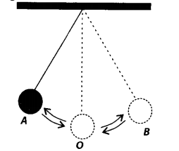
The time period of a simple pendulum is the time taken by it to travel from
(a) A to B and back to A.
(b) O toA, A to B and B to A.
(c) B to A, A to B and B to O.
(d) A to B.

- Boojho walks to his school which is at a distance of 3 km from his home in 30 minutes. On reaching he finds that the school is closed and comes back by a bicycle with his friend and reaches home in 20 minutes. His average speed in km/h is
(a) 8.3
(b) 7.2
(c) 5
(d) 3.6
- The correct symbol to represent the speed of an object is
(a) 10m/s
(b) 10mp
(c) 10m/s¹
(d) 10s/m

Assertion and reasoning
1)Assertion : A vehicle is moving with a certain speed, the driver applies break and again gains speed .
Reason : The vehicle is in non-uniform motion.
2) Assertion :Time period of a given pendulum is constant .
Reason : Time period of a pendulum depends on its length , mass of the bob and the displacement of the pendulum.
3) Assertion: The basic unit of time is minute.
Reason: Speed is normally measured in meter/minute.

Application based / Practical based questions.
- Paheli is travelling with her car . She observed that the odometer reading before starting the car was 12,533 km. After 11 minutes she observed that the odometer reading changed to12,566 km. What was the speed of Paheli’s car in km/min. Also find the speed of the car in km/hr.

- Ram was observing a ball attached to the string. When the ball was displaced, he observed that the ball started oscillating. It was completing 10 oscillations in 12 seconds . Find the time period of the ball. Now Ram started counting his heartbeat with the help of oscillations of the ball, if one heartbeat happens in one oscillation of the ball. How much time will be required for 60 heartbeats to happen ?

Paragraph based questions:
1)Ali was going to a friend’s party on his cycle . For the first 10 minutes he covered a distance of 500 metres . On his way he saw his friend Raj also was going to the party on his cycle. Both of them decided to have a race. Ali covered double the distance (as compared to the first part of journey) in the same time while Raj covered 900 meters .After which they reached the party spot and enjoyed themselves.
- What was Ali’s speed in the first part of his journey?
- Find the speed of Ali and Raj in the second part of the journey .
- Find the average speed of Ali’s total journey.

Short answer questions
- What is time period of pendulum ? Write a proper formula to find the time period of the pendulum .
- Define speed . Write the proper formula for speed , time and distance.
- Write in short about a sundial.
- The average age of children of Class VII is 12 years and 3 months. Express this age in seconds.

CHP 14 : Electric Current and its Effects
MCQ
1)Three bulbs A, B, C are connected in a circuit as shown in figure. When the switch is ‘ON’
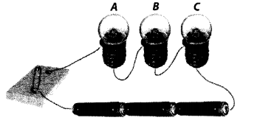
(a) bulb C will glow first.
(b) bulb B and C will glow simultaneously and bulb A will glow after some time.
(c) all the bulbs A, B and C will glow at the same time.
(d) the bulbs will glow in the order A, B and C.
2) Which of the following precautions need not be taken while using electric gadgets/appliances/ circuit?
(a) We should never touch a lighted electric bulb connected to the mains.
(b) We should never experiment with the electric supply from the mains or a generator or an inverter.
(c) We should never use just any wire or strip of metal in place of a fuse.
(d) We should never turn the switch in ON position.
3) Our body is a ________ of electricity.
a) conductor
b) insulator
c) semiconductor
d) none of these

Assertion and reasoning
1)ASSERTION : When excess current is passed through a fuse wire , it melts.
Reason : A fuse works on the principle of heating effect of electric current.
A
B
C
D
2)ASSERTION : A compass placed near a current carrying circuit shows deflection.
Reason : A current carrying wire gets heated due to current flowing through it .
A
B
C
D
3)ASSERTION :A bulb works on the principle heating effect of electric current.
Reason : The electric energy passing through the filament of a bulb gets converted into only heat energy
A
B
C
D

Application based/Practical based questions
- Bhoojo learned about an electromagnet in his school. He wanted to make one such electromagnet. He used an iron nail, wound it with an insulated wire and connected the wire with a cell. He was happy to see that the electromagnet is working , but it was not very strong. Bhoojo wanted to increase the strength of his electromagnet. What methods will you suggest him to increase the strength of his electromagnet ?
2)

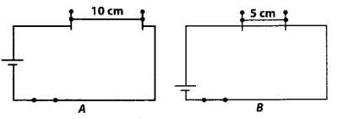
Paheli took a wire of length 10 cm. Boojho took a wire of 5 cm of the same material and thickness. Both of them connected the wires as shown in the circuit given in figure. The current flowing in both the circuits is the same.
(i) Will the heat produced in both the cases be equal? Explain.
(ii) Will the heat produced be the same if the wires taken by them are of equal lengths but of different thickness? Explain.

Paragraph based questions
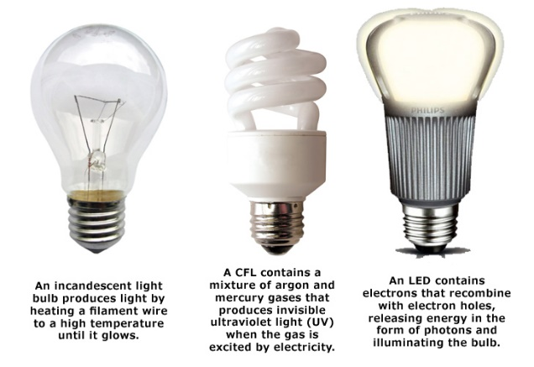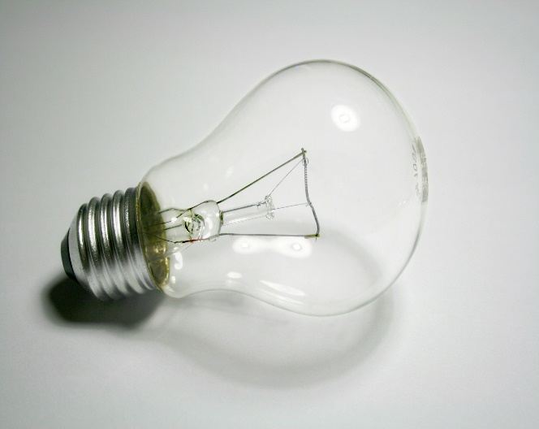
Different typed of electric bulbs

The given figure 2 shows an incandescent light bulb. It consists of a filament enclosed in a glass bulb .The glass bulb is filled with Inert gas or vacuum to protect the filament. Current is provided to the filament by the terminals or wires embedded in the glass. The filament is heated until the bulb glows. A bulb socket provides mechanical connections and electrical support. They have wide range of applications like household and commercial lightings , car headlamp, flashlight and for decorative and advertising lighting.
1)On which principle does an electric bulb work ?
2) The filament in the bulb is made of which material ?
3) Write some applications of electric bulbs
4) What other types of electric bulbs are used now- a-days?

Short answer question
- Explain the principle and working of an electric fuse.
- Who discovered magnetic effect of electric current and when ?
- Give different applications of electromagnets.

CHP 15 : LIGHT
MCQ
- A transparent material which is bounded by both or one spherical surface is known as a …………
- Lens
- Mirror
- Glass
- None of the above
- Which one of the following statements is true ?
- A plane mirror sometimes forms an inverted image.
- A concave mirror always forms a virtual , erect and diminished image
- A concave lens always forms a virtual, erect and diminished image
- All of the above
3)Which of the following is a reflector of light ?
a) The star
b) The sun
c) The moon
d)The filament
Assertion and Reason questions
1)Assertion : When you stand in front of a plane mirror, an erect image of the same is formed inside the mirror.
Reason : Images formed by a plane mirror are laterally inverted.
C
D
2)
2)Assertion :A convex mirror is used in a magnifying glass.
Reason : A convex mirror always forms a real , erect and magnified image.
A
B
C
D
- Assertion :When a white light is passed through a glass prism , you can see a spectrum of different colours.
Reason : White light is consists of seven colours .
A
B
C
D
Application based question
- Bhoojo was travelling through e vehicle . He observed a sentence written on the side view mirror of the vehicle. What is the sentence ? Why is the sentence written on the mirror of the vehicles?
- While doing experiments with concave mirror , Paheli observed that as she changes the distance between the object and mirror the nature of the image formed by the mirror changes. Which type of image can Paheli obtain if she keeps the object very close to the concave mirror?
- Complete the following table . Mention the type of images that can be formed by the different types of lenses and mirrors . One has been done for you.
Type of lens/ mirror | Nature of image formed
- Concave mirror | It can form  1)Real image-  2) Virtual image
- Convex mirror
- Concave lens
- Convex lens

Paragraph based questions
The splitting of white light into its constituent colours is called as dispersion of light. When white light is passed through a glass prism it splits into its component colours. The red colours bends the least , while the violet colour bends the most. The pattern of colour components of light is called the spectrum . Dispersion is also seen in many natural and day to day events.
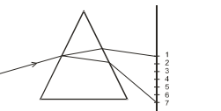
Dispersion of light by a glass prism

- Draw the figure given above and label the colours in the right sequence.
- What is dispersion of light ?
- Give some daily life examples where you can see dispersion of light .
Short answer questions
- What is reflection of light ? Give some day to day examples .
- Light is an important form of energy . Explain.
- A convex lens is called converging lens and a a concave lens is called diverging lens . Give reason.

QUESTION BANK
CHAPTER 16 FOREST OUR LIFELINE
MCQ
Question 1. Which one of the following is the cause of the depletion of water table?
(a) Increasing population
(b) Agricultural activities
(c) Increasing industries
(d) All of these
Question 2. The process of seeping of water into the ground is called
(a) aquifer
(b) infiltration
(c) water cycle
(d) all of these
Question 3. The water below the ground is known as
(a) groundwater
(b) pure water
(c) polluted water
(d) none of these
Question 4. The large well like structure which is used in olden times for rainwater harvesting is called
(a) well
(b) bawris
(c) johad
(d) check-dams
Question 5. Which of the following doesn’t show water shortage?
(a) Taps running dry
(b) Long queues for getting water
(c) Marches and protests for demand of water
(d) Three buckets of water per person per day
SHORT ANSWERS
Q1: What do you understand by anomalous expansion of water?
Q2: Can we keep on drawing water from underground, how it will affect the water table?
Q3: What is rain water harvesting and how it is important?
LONG ANSWERS
Q1: Explain how increasing population is responsible for depletion of water table.
Q2: You have been asked to maintain a garden. How will you minimise the use of water?
Q3: There are ten tubewells in a lane of fifty houses. What could be the long term impact on the water table?

QUESTION BANK
CHAPTER 17 FOREST OUR LIFELINE
MCQ
Question 1. Roof of the forest made by the branches of the tall trees is called
(a) canopy
(b) crown
(c) understoreys
(d) none of these
Question 2. Understoreys are formed due to
(a) different types of crowns
(b) different sizes of crown
(c) different heights of trees
(d) all of these
Question 3. Decomposers convert the dead plant and animal tissues into
(a) clay
(b) humus
(c) inorganic debris
(d) soil
Question 4. Arrange the following components of a food chain in proper sequence – grass, frog, eagle, insects, snake.
(a) Grass → insects → frog → snake → eagle.
(b) Grass → snake → insects → frog → eagle.
(c) Grass → snake → eagle → insects → frog.
(d) All are possible
Question 5. Which one of the following is a role of forests?
(a) Provide food, shelter, water and medicines
(b) Prevent soil erosion
(c) Prevent flood
(d) All the above
SHORT ANSWERS
Q1: Explain, how animals dwelling in the forests help it grow and regenerate.
Q2: There is no waste in a forest. Explain
Q3: What would happen if forests disappear?
Q4: Why forest floor seemed to be dark coloured?
Q5: What are the benefits of residing in nearby forest area?
LONG ANSWERS

Q1: No One Grows Trees In The Natural Forests” – Comment.

Q2: A Forest Act As The Purifier Of Air And Water” – Justify Your Answer.

Q3: What Does Happen, When After A Certain Period Of Time The Plants And Animals Die?

QUESTION BANK CHAPTER 18
WASTE WATER STORY
MCQ
Question 1. Water that is not fit for use is called
(a) clean water
(b) wastewater
(c) both (a) and (b)
(d) none of these
Question 2. Which of the following is not a source of wastewater?
(a) Sewers
(b) Homes
(c) Industries
(d) Hospitals
Question 3. The period of International Decade for action on ‘Water for Life’ is
(a) 2000-2010
(b) 2005-2015
(c) 2010-2020
(d) 2003-2013
SHORT ANSWER QUESTIONS
Question 1. Why can’t sea water be used for drinking purpose?
Question 2. Write the full form of WWTP.
Question 3. Give examples of some contaminants present in sewage.
LONG ANSWER QUESTIONS
Question 1. What is vermi - processing toilet? Explain.
Question 2. List various steps involved in waste water treatment.
Question 3. Name various components of sewage

